The Making of the Scottish Working Class
The goal of this research paper will be to take the philosophies set forth by Thompson, and the notion of bottom-up history and apply it to villagers in Scotland, primarily in Bo'ness and Cambuslang. Thompson manages to give agency to groups of people that never had it before and then explains their purposes through the overall aspects that they encountered. These two villages will be examined by using the Carmichael family as an example, and explaining how their experiences are in many ways descriptive of other people during the same time and similar towns.
To understand the society of where the analyzed group comes from, where they lived, and their occupations must be known. Census reports give the information for both questions. This data is supplemented with "family group sheets" from genealogy research on Ancestry.com which will contribute additional questions into the research. And a multitude of photos will be used to help explain the outlook of the society, along with statistics.
When it comes to discussions of social history, E.P. Thompson is, of course, one of the leading architects to explore, as is Ralf Dahrenforf Ralf., and Anthony Lincoln. Paul Buhle offers an updated look at E.P. Thompson’s work and how it is interpreted today. But to connect the English social histories to Scotland, Arthur Herman and Thomas Devine’s work is to be used. These books will help explain the social structure and problems faced by the Scottish people that will be brought up in this paper.
It is easy to say that the working citizens of the Scottish villages were merely just that, a working section of society. The harder aspect than is to give them agency, and voice. By exploring the coal mines, Steel mines, and paper mills that the villagers of Bo’ness and Cambuslang commonly worked at, their agency can be seen. The agency is through any trade unions, housing conditions, personal groups such as the Loyal Orange Institution of Scotland and the Freemasons, as well as attending and playing sports. The goal is to explain the common Scottish workers’ by going beyond just their work life in the “working class” and into the public sphere. The concept of the social class does not contain exact parameters, and is instead a term given to a group of people. Who is in a social class depends from class to class. For this paper, the term working class will be used to define the individuals that perform manual labor as their main means of life.
The Making of the Miner’s Life
The making of the Scottish working class begins for this study in 1860 in the small city town of Bo’ness. The group analyzed were primarily Coal Miners for much of their family history. In the cities that the family was from; Bo’ness, Cambuslang, Old Monkland, and Kilwinning all were industrial cities using the industrial revolution to their advantage. The family spent the most time in Bo’ness and Cambuslang, and these two cities will, therefore, be analyzed in depth. Coal mining was a common profession for many Scottish workers. As time went on the family began to work in different areas such as steel mines, paper mills, and dye shops. This was also similar to the changes that other Scottish workers endured throughout the same period.
Bo’ness
The Carmichael family started out in Derry Ireland as the Michael’s and then moved into Bo’ness Scotland around 1860s chasing the collieries. The family grew in Bo’ness as James and Elizabeth Michael began to have kids. Their four daughters worked as seamstresses and domestic servants like their mom Elizabeth, while the sons followed James’ footsteps and took on coal mining. The principal collieries of the town consisted of Borrowston Coalfield and Bo’ness Coal Works. Unfortunately, it is unknown of which collieries that they worked. Because people, especially the Carmichael family, married other people that held a similar profession, the jobs were passed down from one to the other.
The Michael family, which would eventually become the Carmichael’s, overwhelmingly held the job position of “hewer” inside the coal mines. Being a hewer was one of the most dangerous positions to work in the mine as they worked with dynamite and other explosives. They also crammed themselves into tight areas to set off the dynamite. Shrapnel and excessive coal dust were common for the hewer to breath. Hewers were underground miners. This led to the possibility of an accidental death or serious injury which were quite frequent, unfortunately. Luckily this set of miners managed to escape the death and injury, but many others were not as lucky. It is surprising that although being a hewer was one of the most dangerous professions in the coal mines, the job was passed down from father to son for so long. This proves that moving up in the social order of the coal mines was just as difficult as moving up in the social order of society. Other popular jobs in a coal mine that were ranked above underground mining were surface level mining, coal preparation, mine support, and supervisors.
About thirty years after arriving in the small town of Bo’ness the family was forced to find a new place to live due to the closing of the collieries in the area. The new location was Cambuslang, eastward of Bo’ness on the outskirts of the major city of Glasgow. It was a bigger city than Bo’ness and a more urbanized one at that. The industrial revolution helped build Cambuslang up, and diversity the industries in the city. By feeding off the port city of Glasgow, Cambuslang grew as a workers’ industrial town. Many families in the working class moved into different cities across Scotland as they followed the coal mines and any other industries that were offering work at the time.
Cambuslang
Thomas Michael was the first to call the Cambuslang coal mines his home. Somewhere along his trip from Bo’ness, he changed his last name to be Carmichael. Why he did so is unknown, but his actions were nothing too far out of the ordinary for the working class during this time as many family names changed for a wide variety of reasons. With a new name, and in a new city, the life of a working-class citizen was ever changing.
Housing in Cambuslang were multi-family apartment complexes that were owned and operated by the collieries. It was not an extravagant life, saying it was comfortable would probably also be a stretch, but it was the life that they were given from their contract with the coal mines. The reason for the multi-family apartments was rooted in the overcrowding of urban centers in the late 1800s. The influx of urban residents came from the industrial revolution’s push into urban centers. The colliery workers usually did not have to pay for their housing, and if they did the price was not much since they were working for the owners of the land already. In the housing district, a firm feeling of community was present. Everybody watched out for each other, so much so that people outside of the coal mining community would not enter these neighborhoods. Derogatory terms were given to the coal miners from the outside community. Following the collieries from city to city was a common endeavor for many of the Scottish coal mining families. As one coal mine in a city closed up, another would open somewhere else. John Anderson explains how it was not uncommon for representatives of other collieries to go into another city and try to recruit new workers. Also, advertisements often popped up in newspapers.
To receive the benefits of working for the collieries such as housing, pay, exclusion from taxes and military service a contract had to be signed that connected them to the coal mine for a set amount of time. Effectively, the given collieries owned the worker. This allowed for the companies to treat the employees harshly with long days, minimum pay, and little reward in the benefits that were provided for a life of hard work in dangerous conditions. Also, a worker was not allowed to terminate his contract before it was up, but the mining company had the privilege of doing so whenever they pleased.
Eventually, in Cambuslang around the early 1900s, the industry started to change from primarily collieries to Steel mines, paper mills, and Dye Works. This change was imparative as it showed the creation of new sectors of work for the Scottish working class. The main companies that operated during the time were Hallside Steelworks, Clydebridge Steelworks, Rosebank Dye Works, and Gilbertfield Pit. Unlike the former collieries and a few of the steel mines, the companies in charge of the new industries did not take an initiative of themselves to provide extra for their employees.
Housing now was not offered, and the previous benefits of exclusion from taxes and the military were not applicable anymore. But even without these benefits, the population of the small city still rose drastically during the turn of the century. The increase in population can be directly associated with the variety of occupations that became readily available in Cambuslang.
The making of the Scottish working class was definitive of the struggles of being a Scottish citizen. Not all Scottish citizens were manual laborers, but they did all experience the struggles of being Scottish. The struggles of being in a lower class than their English counterparts just because they live in Scotland is similar to the working class that found themselves below everybody else in the class struggle of society. But in this struggle, the working class managed to grow and become a unique group of people completely different from any other group. Thus, the “making of the Scottish working class” happens similarly to E.P. Thompson’s explanation of the English, as a process that just happens. This process is the generational movement from city to city in search of work, as well as the passing down of traditions in the aspect of type of labor. Over time the process of passing down loses the original elements that were there and creates a social migrant that moves between the classes. This process in the manual labor working class, but also present in other professional sectors of society. The making of the miner’s life then takes place as a description of where they worked, lived, how much money they made and the financial stability or lack of that they encountered.
Sociability and the Competent of Identities
The making of the Scottish working class was forced to spend long hours in the mines or factories. But even with long hours, it cannot be forgotten that working was not the only aspect of the working classes life. To fully understand the worker’s life, giving them agency will help uncover what their actual lives of sociability and the competent of identity was. The aspects of trade unions, Freemasonry and the Loyal Orange Institution, as well as football and boxing, will be used to give agency to the working class to show their lives outside of work.
Trade Unions
Trade unions have always been an asset to a worker in their push for equality and fairness across the board. Trade unions have been around for a very long time in a wide variety of different professions. Therefore, it should not be of much of a surprise that coal miners were also involved in unions. But what is surprising is the extent of their involvement. Most manual labor workers were highly active in unions, but for coal miners, union activity varied from time to time. Originally there was not a national union to accompany all of the workers, but instead just locally ran ones. This ended up changing with the creation of a few different national unions such as the National Association of United Trades and the Coal and Iron Miner’s Association of Scotland. These national unions were created to benefit the miners, while also upholding the corporate aspect to ensure that the businesses still managed to be profitable. Although in the early days they were not very popular, trade unions soon became completely necessary in the collieries.
The biggest aspect of a trade union is their ability to call and force a strike to take place. Mining strikes were very rare until the emergence of the different national trade unions that were created to unite the workers. Strikes quickly became a constant occurrence in Scotland as many miners had poor relationships with their masters. Several strikes had taken place in Cambuslang, but arguably the most impactful were the 1926 strike. This strike completely stopped railways, and other transport services, newspapers stopped being printed and in all Scottish trade came to a standstill. The strike also put many people out of work and pushed them to find jobs in other industries.
Trade Unions helped ensure a level of safety and security financially and physically for Coal Miners, and then steel, paper mill, and other laborers. Being in a union is in many ways essential to guaranteeing success among the collective group of workers. Scottish workers were involved in trade unions to maintain a sense of self-virtue and personal time, which was spent doing a wide variety of activities such as being involved in lodges or sports. Trade union involvement helped guarantee the time set aside to participate in these activities or to just be with the family.
Freemasons
Freemasons is a fraternal organization that has been around in Scotland since the 1600s. Freemason lodges are a common meeting ground for people from all backgrounds that run on the aspect of self-righteousness and desire to make the world a better place. This meeting ground for people of all backgrounds is an example of Pierre Bourdieu’s description of social interactions to connect with people from another social class other than your own. In doing so, one can potentially understand what it will take to move into the higher social class.
At the root, Freemason lodges were sociability clubs for men to “talk, joke, drink, eat, and sing.” The focus was on brotherhood and friendship, not religion and politics. Because of this goal, Freemasonry was very popular among the working class as it was with the higher up social classes. But in the 1800s in Scotland, people in a high social class such as lawyers and doctors funded their own lodges. This did change in the turn of the century as lodges started to become more inclusive. Depending on where a lodge was located had a large impact on the diversity of the men that were a part of it. Cambuslang being a city comprised mostly of manual laborers most likely would not have had much higher social class citizens apart of it.

Loyal Orange Institution of Scotland
Another lodge of importance for the working-class citizens was a religious oriented one. These were not necessarily in an actual church format, but instead, they were a meeting ground for people of a particular background. For the Carmichael family in Cambuslang, this lodge was the Loyal Orange Institution of Scotland, a Protestant organization loyal to their religion. There were other similar groups for other faiths. The group emerged around 1876 as very popular in areas that had a large working class contingent. As previously stated, Cambuslang was a working-class society; therefore, it is not surprising that the Orange Order was famous there. Glasgow was in fact home to two-thirds of the total Scottish population involved in the Orange Institution, which Cambuslang is on the outskirts of.
Similar to Freemasons, the Loyal Orange Institution ran on similar ideals of brotherhood and loyalty. It was often viewed as a fraternity although women were eventually accepted into the organization as time went on. But unlike Freemasons, it was an ultra-religious group meant to maintain Protestant ideas. This caused them to be very anti-Catholic and have practices that showed that. After many religious problems in Scotland slowly came to an end or at least were pushed under the rug, the Orange Order turned to being just a celebration of the Protestant religion.
The Carmichael family was very involved in the institution. Andrew and May Carmichael met there as they were both a part of the Orange band. Stewart McDougall recalled his experiences with Andrew and May while being actively involved there growing up. He explained how the experiences were ones that he would never forget, especially the parades.
Football
Outside of lodges, sports were a common area of sociability for laborers. Football was a main game for the workers as it was cheap to play and watch at the time. The Cambuslang Rangers was the local amateur team that captured the support of the citizens in the city. In the early years, the team was comprised of miners or their sons. With miners being directly involved in the team, going to their training sessions and matches after their shift most likely became a daily venture for many of them.
Outside of Cambuslang, Queens Park Football Club was the important “professional” club for laborers to attend to. Although they were technically a professional football club, they still ran on as an amateur club which was overall appealing to much of the working-class. Tickets to matches were, therefore, affordable because of this reason in mind. Queen’s Parks working-class attitude brought them much success in professional competitions and set the standard for football clubs in Scotland. Although they have lost their popularity over the years, the club’s popularity among the working-class has not changed much. This is an aspect of the club that has remained the same since they were founded.
Boxing
Boxing, like football, was primarily a laboring sport for people in a middle or lower class. Because of the brutal nature of the sport, citizens in the higher classes usually did not participate in the competition. Like football, it is also a very cheap game to play and until recently was a cheap to watch. This alone added to the popularity of boxing and made it very appealing to Scottish workers. Therefore, it was an important aspect in the making of the Scottish working class.
This helped give workers a way to not only exercise, but also exercise their freedom and anger that may have been boiling up. By taking a look at boxrec.org, it can be seen that many of the Scottish boxers were brought up in industrial towns. For example, Johhny Brown who married into the Carmichael family was a fighter out of Hamilton, which was also an industrial city. He had a professional career that ran from 1920 to 1931 with forty victories, thirteen losses, and two draws. He enjoyed a successful boxing career, but a career in boxing alone was not sufficient as he still had to continue working part time in a coal mine, and full time after he retired from boxing.
These five categories are significant sociability aspects of the making of the Scottish working class. Although these are not the only five points, they are some of the main ones the Carmichael family was involved in. In all, the combination of the different social aspects of the Scottish workers along with their working history helped create what it meant to be in the Scottish working class, and how everything added up together was the making of this identity.

The Desire to Migrate
The desire to migrate for many is often always present. A burning urge to pack up and leave to look for a new and better life could be a dream for some, a reality for others, and a desire for most. It is important to remember that migration can be from country to country, city to city, or one part of a city to another part of that same city. In this desire to migrate the character of a person can be unrevealed. It will be seen through the analysis of immigration from Ireland to Scotland, Bo’ness to Cambuslang, and Scotland to the United States to understand the mind frame behind the making of the Scottish working class and their desire to change themselves.
Getting into Scotland
At some point between 1851 and 1861 the then Michael family decided to move from Derry Ireland to Bo’ness Scotland. James Michael was an Iron Stone Miner in Ireland; he moved to Bo’ness to become a Coal Miner. For James to make that decision with Elizabeth times had to have been hard in Ireland. Most likely being an Iron Stone Miner was not making ends meet and therefore they were forced to try and find a new way to survive. With no kids to move with them the decision to relocate had to have been a bit easier to make than it otherwise may have been.
According to the 1861 Census, James became a coal miner in Scotland. How he was intrigued into Scotland is the central question. One very real possibility is that employees from the Scottish Coal Mines were in Ireland recruiting workers for the vastly expanding enterprise of coal mining, they also may have seen a newspaper ad from one of the Scottish collieries. Many companies did do this, and it would not be surprising if this was the case. Another possibility is that maybe a family friend or another family member had already made the move to Scotland, and James and Elizabeth were following in their footsteps upon receiving word of the success that they were enduring there.
Whatever the reason was for them deciding to move to Scotland it nevertheless changed who they were forever. Many of the Scottish coal miners reported to being from Ireland or Whales originally. They effectively became the making of the Scottish working class once they began to work in Bo’ness Scotland, or whatever city that they settled in. But it must be remembered that the making of this new Scottish working-class identity is only possible because of the beliefs, philosophies, and rationale that they took with them from Ireland. One can physically leave a place, but remnants of the old area will always travel with them.
Inner country migration
Once inside Scotland, many workers eventually had to make the decision to move into a whole new city or a new area of the city that they were currently living in. Once again, deciding to migrate, even if it is not very far, is never an easy task to decide upon. Many variables that go into the decision such as work, housing, and the general aspect of making it collaborate with the family. For a family to decide if it is necessary for them to migrate within the country they must weigh these variables and make the best logical decision.
The Carmichael’s, like many Scottish coal mining families, moved from one city to another inside of Scotland. The cities that come up on the Census reports are Bo’ness, Old Monkland, Kilwinning, and Cambuslang. A vast majority of the family though went from Bo’ness into Cambuslang as they chased the collieries. As previously stated it is unknown why the collieries in Bo’ness shut down, maybe bankruptcy or lack of coal, or if they did completely shut down at all. A possibility is that layoffs were conducted or were said to be going to take place. But nevertheless, Cambuslang became the new home for the Carmichael family as it did for many other Scottish miners at the time. Because the coal mines of Cambuslang were newly opening, there were many positions needing to be filled, and that attracted many laborers to the area.
Thomas Michael moved to Cambuslang with his housewife Agnes. They had no kids at the time. By having no children, it had to have been easier for them to decide to make a move, whereas an established family most likely would have had a harder time deciding upon relocation. Anderson points out that he started his family in the city he worked in and many of his coworkers did the same. This is proof that many people did not move with their whole family into a new city, but instead, would move and then start a family there, and once established they would tend to stay in that area. This tends to be still common today. For Scottish miners moving into a new Scottish city, their class identity would still have to shift much more than one may realize. Because of the diversity of Scotland between cities in dialect, religion, among others, going from one to another would create changes in how a person saw oneself.
Desires to leave Scotland
After living in Scotland and enduring the pressures that were day to day Scottish life, many people decided that they needed to get out of the country to be successful and live out their dreams. Leaving the country is a major form of migration that was always the easiest to achieve. To migrate legally out of the country, a multitude of paperwork would have to be completed on top of having to find a place to work and live. These aspects combined with the notion of trying to fit into a new environment had stress factors all over it for the migrator.
In the Carmichael family tree, Elizabeth Michael was the first to move to the United States with her coal mining husband Matthew in 1882. They moved back to Scotland for at least ten years from 1891 to 1900 before returning to the states where they ended up dying in the 1920s.. According to the birth certificates, the three children born in the United States were born in Illinois, Iowa, and Kansas. It seems the family was never able to create a solid foundation for themselves. It is unknown if the any of the kids ever returned to the United States as their death certificates are not accessible, but Elizabeth and Matthew did return according to their certificates.
The next three Carmichael’s to move out of Scotland were once again females in Elizabeth Baird Carmichael to Illinois, Agnes Carmichael to California, and Ann Carmichael to California. A correlation seemed to be present; the Carmichael women were more likely to leave the country with their new husbands than their male counterparts. This may have been due to lack of choice in the say so more than anything. None of the women returned to Scotland to live.
The first Carmichael male to leave Scotland was John Mullen Carmichael. As a steel mill worker, he left Scotland for the United States in search of work leaving his wife Annie Farren behind. He arrived in 1928 aboard the ship “Regina.” But their experience in the United States was cut short as they were deported back to Scotland when the Great Depression broke out. He was not forcefully deported; John decided on his own will when given the option by the US Government to either return home on a paid trip or wait out the depression with everyone else. It is clear that John’s migration was a failure as he was not able to stay where he moved to as his sisters managed to. But his failure would only prove to be motivation for his sons who four of the five would eventually move to California in search of a new life.
The last and most current wave of migration out of Scotland for the Carmichael family happened with first Robert in the 1950s followed by his brothers George, Alexander, and lastly Andrew in the 80s. The migration was done through a sponsorship program where one sponsored the other in order to prove that they had enough funds in the family to be self-supportive.
The making of the Scottish working class began to be faced with the decision of having to leave their country or stay in search of work. Deciding to leave did not guarantee work, and could have just as easily caused problems. In the United States, the new immigrants were faced with the problem of carrying stereotypes with them such as being drunks and lazy, even if they were not. This forced them to try and change their language, behavior, and actions to attempt to fit into the larger social scale of what was the United States ideology at the time.

Conclusions
The making of the Scottish working class is an ever-changing group that has no definitive inclusion or exclusion among its members. It is not an actual class by any standard because of how wide the range is what is classified as a “Scottish worker.” Therefore instead of this being a class analysis it is an analysis, of Scottish laborer’s that make up a small majority of the entire Scottish working-class. The term Scottish working-class is then a loosely used term to describe this group of people. This research uses E.P. Thompson’s idea of giving agency to a group of people that never had it before in order to explain larger social issues that were present in the area. Thompson’s research strategy is very meticulous, and thus this research does not attempt to replicate any part of his strategies.
The Carmichael family exhibits the Scottish “work ethic” of hard work, patience, and persistence from the time they entered Scotland all the way till today where a core group of the family that has not migrated still lives. It is these laborers that help tell the story of Scotland. Not the Hollywood “Braveheart” one that many are accustomed to knowing, but the story of Scotland as being the poor nation in the shadows of the British crown that suffers in a slight identity crisis as they struggle to be something completely different than the English, but while remaining British and maintaining the values of being a true Scot. The identity of all of Scotland, from the highest of classes, to the lowest, and the bourgeoisie in between distinguish this. The making of the Scottish working-class, rooted mostly in the lower order of the bourgeoisie, give insight into the struggles of the manual labor field, the problems of association in sociability, and the present desire to migrate as an attempt to better their lives.
What it means to be the making of the Scottish working-class is realized in every area of their lives, from every aspect of the work they do to various parts of the sociability that they take part in, and finally to the different factors of migration that were interwoven in their lives. This social class is made through the analyzation of these different points and bringing them back together to be a complete whole.

Figure 1: 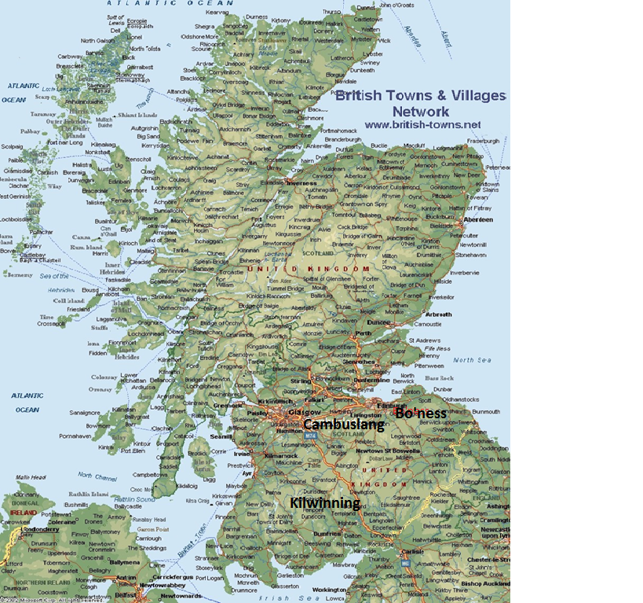

Figure2:
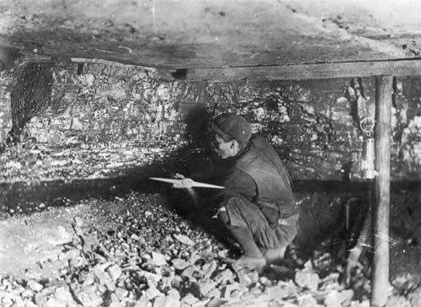
Figure 3: 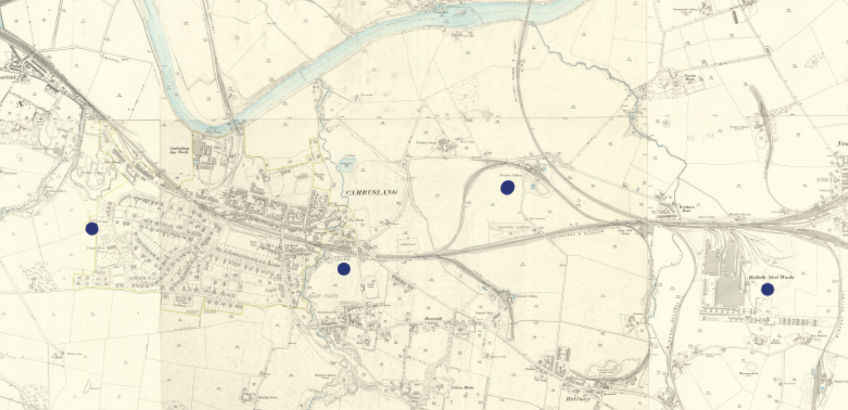

Figure 4: 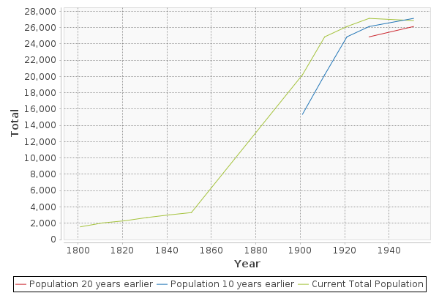

Figure 5:
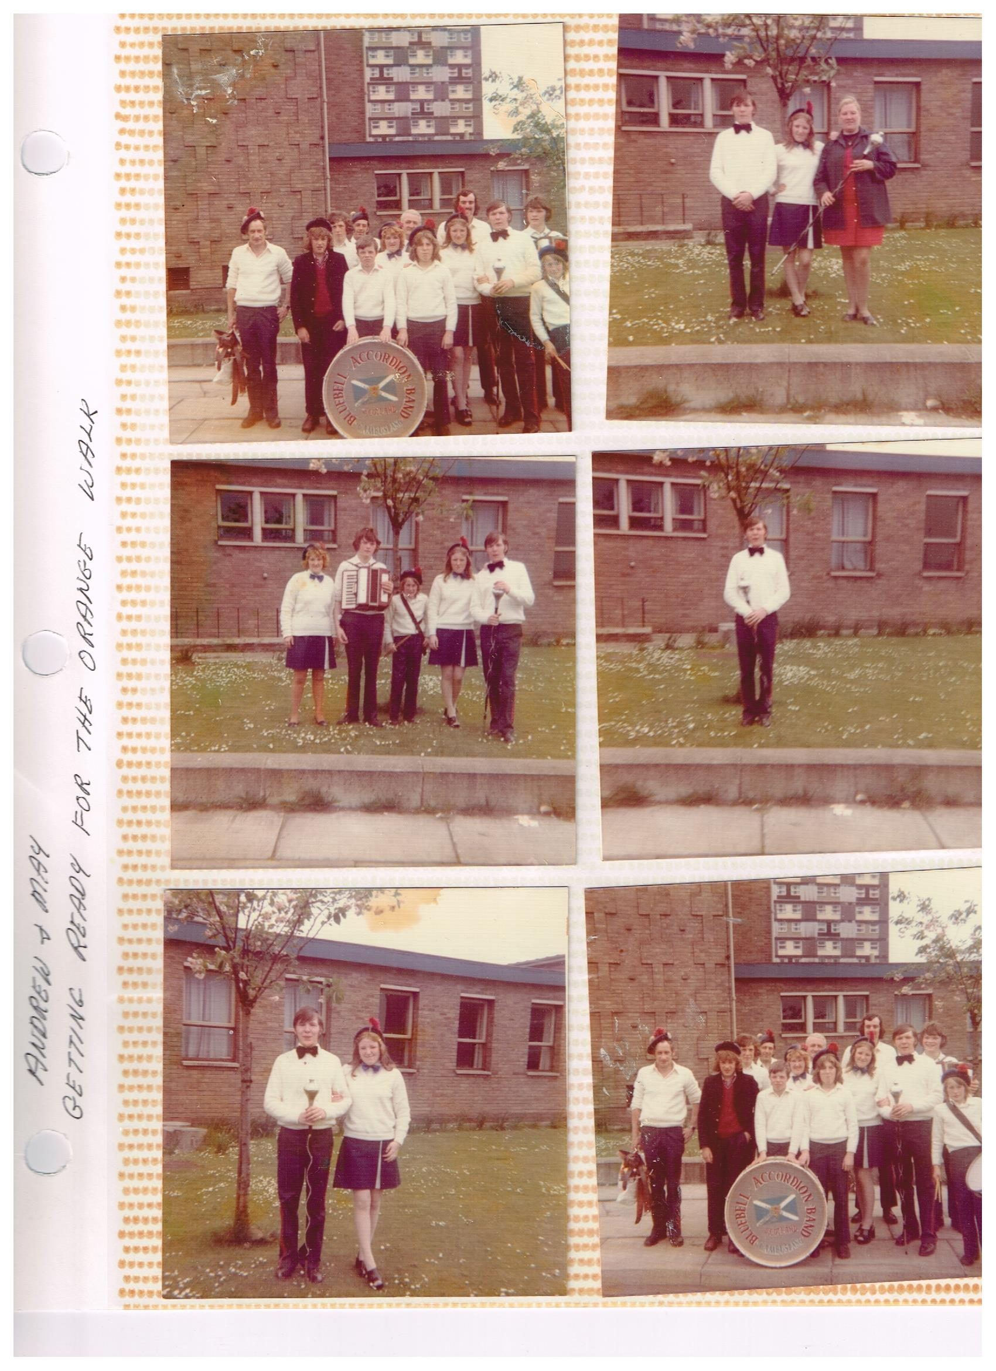
Figure 6:

***
Special Thanks to my friends and family that have completely assisted me in getting this research completed, especially Sara Flores. Without the tireless genealogical work of my grandparents, Judy and Robert Carmichael, this research would have never got as far as it did. Also, thank you to Colin Findlay and Edward Boyle for granting me permission to use their original research and websites. Lastly, thank you to Dr. Flamein for helping me every step of the way in my research process.

Bibliography
Primary Sources:
1851 Ireland Census
1861 Scotland Census
1871 Scotland Census
1881 Scotland Census
1891 Scotland Census
1901 Scotland Census
1911 Scotland Census
1921 Scotland Census
1931 Scotland Census
Birth Certificates of Elizabeth Michael, husband Matthew Hawthorne, and all eight of their children.
Deportation documents of John Mullen Carmichael
Interview with Sandy Carmichael. Lakewood California. March 28, 2017
Interview with Stuart McDougall. Los Alamitos California. March 27, 2017.
Manifest of the ship Elysia that sailed from Glasgow, Scotland to New York, United States.
Manifest of the ship Regina that sailed from Glasgow, Scotland to New York, United States.
Photograph of the Orange Walk
Photograph of Robert Carmichael
Robert Carmichael’s Freemasonry Artifacts.

Books 1800’s-1959:
Anderson, John. Coal! A History of the Coal Mining Industry in Scotland with Special Reference to the Cambuslang District of Lanarkshire. Glasgow: R. E. Robertson, Ltd., 340 Main Street, 1943.
Dahrendorf, Ralf. Class and Conflict in Industrial Society. 1959.
Lincoln, Anthony. Social and Political Ideas of English Dissent, 1763-1830. Cambridge, 1838.
Robinson, Richard. History of the Queen’s Park Football Club 1867-1917. Glasgow, 1920. Scottish Football Historical Archive.
Books 1960-2017:
Bourdieu, Pierre. Distinction: A Social Critique of the Judgement of Taste. Massachusetts: Harvard University Press, 1984.
Gualejac, Vincent De. Paradoxical Capitalism: A System That Goes Crazy. Seuil: Paris 2015.
Herman, Arthur. How the Scots Invented the Modern World: The True Story of How Western Europe's Poorest Nation Created Our World & Everything in It. New York: Three Rivers Press, 2002.
James, Blair. Queen’s Park Football Club. Stroud, United Kingdom: The History Press, 2007.
Thompson, E.P., The Making of the English Working Class. United States: Vintage Books, 1963.
Wilson, Rhona. Old Cambuslang. United Kingdom: Stenlake Publishing, 1996.

Articles and Websites:
“A History of the Scottish People Patterns Of Employment In Scotland 1840-1940” https://www.researchgate.net/publication/237728854_A_HISTORY_of_the_SCOTTISH_PEOPLE_PATTERNS_OF_EMPLOYMENT_IN_SCOTLAND_1840-1940.
Ancestry.com. Family History Sheets. Genealogy Research completed by Judy and Robert Carmichael.
Britanik, Henry Louis Gates Jr and NEHGS Researcher Meaghan Siekman, Kristin. “Why Did My Ancestor Change the Family Name?” The Root. Accessed April 12, 2017. http://www.theroot.com/why-did-my-ancestor-change-the-family-name-1790874952.
Boyle, Edward. Views of Old Cambuslang. http://www.edwardboyle.com/EB/Cambuslang/Cambuslang.html. Edward is a historian on Cambuslang. His website contains a variety of sources to other documents that he has come into contact with over the years.
Buhle, Paul. “E.P. Thompson.” Monthly Review: An Independent Socialist Magazine 66, no. 5 (October 2014): 53–58.
“Cambuslang | As Described in F.H. Groome’s Ordnance Gazetteer of Scotland (1882-4).”. http://www.visionofbritain.org.uk/descriptions/92900.
“Cambuslang - Scottish Mining Website.” http://www.scottishmining.co.uk/235.html. Included in this website is a large amount of primary and secondary documents. When cited throughout the research paper it will be noted as “name of the website, followed by the name of the page on the website.”
“Cambuslang ScoP through Time | Population Statistics | Total Population.” http://www.visionofbritain.org.uk/unit/10016903/cube/TOT_POP.

Dinnie, Gordon. http://gordondinnie.com/Clang.html. This is a personal site of a Cambuslang resident that uploads pictures and postcards. Ran by Gordon Dinnie
Findlay, Colin. Cambuslang Industrial History. 22 November, 2013. http://www.edwardboyle.com/EB/Cambuslang/History/Cambuslang%20Industries%20C%20Findlay.pdf
Findlay, Colin. History of the Iron and Steelwork Industry in Scotland. http://myweb.tiscali.co.uk/clydebridge/Brief%20History.html
History of the Orange Order. http://www.orangeorderscotland.com/History%20of%20the%20Orange%20Order.pdf
Robinson, Richard. “History of the Queen’s Park Football Club 1867-1917.” (1920)
Stevenson, David.“Four Hundred Years of Freemasonry in Scotland.” The Scottish Historical Review 90, no. 230 (2011): 280–95.
Masonic Service Center 8120 Fenton Street Silver Spring, MD 20910-47850. “Who Are the Masons?” Accessed May 2, 2017. http://www.yorkrite.com/mason.htm.

Knox, WW. A History of the Scottish People Urban Housing In Scotland 1840-1940. http://www.scran.ac.uk/scotland/pdf/SP2_4Housing.pdf.
Kaufmann, Eric. “The Orange Order in Scotland since 1860: A Social Analysis.” http://www.academia.edu/13444847/The_Orange_ Order_in_Scotland_since_1860_A_Social_Analysis.
Wilson, Gordon McAndrew. The Miners of the West of Scotland and their Trade Unions 1842-74. Scottish History, University of Glasgow. January 1977.

E.P Thompson’s highly celebrated work, The Making of the English Working Class, has been an overly important book on the shelves of many British Historians, as well as for Marxist theorists. Much of the overall amount of research pertaining to the English has done a great amount for that group of people, but not much has been done on the Scottish. By taking the same concept presented in Thompson’s work that gives agency to people that never had it before, and applying it to the Scottish society, much can be seen in regards to the Scottish working class and their ideological creations, and influences.
Census Data for every ten years dating from 1860’s to 1950. The census data documents are copies of the originals taken from the Scottish Archives. The bulk of the primary documents for this research comes directly from these census reports.
Group Family Sheets are overviews of personal people, their spouse, and kids. These are important to show the family structure, and they have additional information not found in Census reports. The additional information is birthdate, date of death, religion, and additional groups that a person may have belonged to.
“Cambuslang Photos,” accessed February 21, 2017: http://www.edwardboyle.com/EB/Cambuslang/Cambuslang.html. Edward Boyle is a Cambuslang Historian whose personal website is full of photographs that he has collected throughout the years. There are also links to other resources, but most the site consists of photographs. Boyle granted permission to use any photographs on the site in the research.
Ralf. Dahrendorf, Class and Conflict in Industrial Society, (1959).
Anthony Lincoln, Social and Political Ideas of English Dissent, 1763-1830, (Cambridge 1838).
Paul Buhle, “E.P. Thompson,” Monthly Review: An Independent Socialist Magazine 66, no. 5 (October 2014): 53–58. The Making of the English Working Class has socialist Marxist overtones (55).
Arthur Herman, How the Scots Invented the Modern World: The True Story of How Western Europe's Poorest Nation Created Our World & Everything in It, (New York: Three Rivers Press, 2002).
Thomas Devine, The Scottish Nation: A Modern History, (London: Penguin Publishing, 2012). This book highlights the social and economic structure of modern day Scotland. The aspects that are explained here are important to explaining the current state of affairs in Scotland. It will be an important cross referencing point in order to compare prior aspects of Scottish social and economic structure with the current structure that is taking place.
“Cambuslang - Scottish Mining Website,” accessed February 15, 2017. http://www.scottishmining.co.uk/235.html. The list of coal companies, and number of employees are listed for Cambuslang. This particular list shows the housing districts that were owned and operated by these companies.
“A HISTORY of the SCOTTISH PEOPLE PATTERNS OF EMPLOYMENT IN SCOTLAND 1840-1940 (PDF Download Available),” ResearchGate, accessed February 16, 2017. https://www.researchgate.net/publication/237728854_A_HISTORY_of_the_SCOTTISH_PEOPLE_PATTERNS_OF_EMPLOYMENT_IN_SCOTLAND_1840-1940.
Rhona Wilson, Old Cambuslang, (United Kingdom: Stenlake Publishing, 1996).
Figure 1: Map of Scotland. The three cities where my family had come from are in bold font. These are three main cities, but Cambuslang and Bo’ness will be the center of the research for the paper.
1861 Ireland Census, and 1881 Scotland Census.
“Bo’ness & District - Scottish Mining Website,” accessed March 14, 2017, http://www.scottishmining.co.uk/479.html. It is important to note that it is unknown exactly what company members of the Carmichael family worked for because of insufficient notes were taken by the coal companies. The only records kept in regards to employees were for anybody that was injured, or for the managers. The typical employee was paid in cash, but records do not exist about the pay either. It is noted by historian Colin Findlay that collieries would destroy documents upon bankruptcy, and many documents fell victim to fires.
Pierre Bourdieu. Distinction: A Social Critique of the Judgement of Taste. Massachusetts: Harvard University Press, 1984. Taken from the ideas of Max Weber, love is social, and therefore marriages often occur between people of a similar social background.
“Occupation, Coal Miner, Hewer” comes up in multiple family history reports from Ancestry.com. It is unclear where Ancestry.com retrieved this information. Hewers were the workers that went in and blew up parts of the mines to loosen up the coal.
Figure 2. https://goo.gl/images/2dzwLX; This is an image of a hewer at work. As can be seen, he is fit tight into a small area as he works with his pick ax to loosen up the coal. Note that he does not wear any protective clothing, no gloves, hat, or face mask to keep out the coal dust. He is surrounded on all sides in the mine and does not have enough room to completely stand up above his head. Hewers were underground workers and therefore ranked below many of the other jobs at the mining site.
“Accidents 1915-1925 - Scottish Mining Website,” accessed March 14, 2017, http://www.scottishmining.co.uk/342.html. And, “Bo’ness & District- Scottish Mining Website.” The documents presented on this website are the collection of accident reports kept from the companies working in Bo’ness and Cambuslang. Neither contained any names of the Michael or Carmichael family. Please note, there is a possibility that the family used to work for a smaller colliery that did not keep any documents at all, or that they were involved in an accident but it was not life threatening or end in death.
Herman, How the Scots Invented the Modern World, 161-89. “But they were first to recognize it for what it was and to realize how economic growth could suddenly transform an entire society for (on the whole) the better. As the century proceeded, merchants, scholars, clerics, and professional men-a Scottish middle class pushed themselves front and center…the epicenter of this transformation was Glasgow.” (161).
Colin Findlay, Cambuslang Industrial History, 22 November, 2013. http://www.edwardboyle.com/EB/Cambuslang/History/Cambuslang%20Industries%20C%20Findlay.pdf. “Cambuslang ScoP through Time | Population Statistics | Total Population,” accessed February 16, 2017, http://www.visionofbritain.org.uk/unit/10016903/cube/TOT_POP. The population data explains how the overall population of Cambuslang began to grow from the late 1800s into the 1900s. This population growth is from the growth of industry that took place during this time.
Henry Louis Gates Jr and NEHGS Researcher Meaghan Siekman Britanik Kristin, “Why Did My Ancestor Change the Family Name?,” The Root, accessed April 12, 2017, http://www.theroot.com/why-did-my-ancestor-change-the-family-name-1790874952. And 1901 Scottish Census. There is a belief among the Carmichael family that Thomas changed his name in response to his brother James changing his, who may have been in trouble with the law. James also had married three women during his life, possibly a money issue somewhere down the line.
Figure 3. The major coal mines of Cambuslang are labeled with a “blue” dot. As can be seen, the collieries are often located away from the major living quarters of the city. The dots indicate the location of the collieries above ground operations; the underground mines could potentially extend for miles away from the point of entry above ground.
WW Knox, A History of the Scottish People Urban Housing In Scotland 1840-1940.
John Anderson, Coal! A History of the Coal Mining Industry in Scotland with Special Reference to the Cambuslang District of Lanarkshire, (Glasgow: R. E. Robertson, Ltd., 340 Main Street, 1943), “They were wholly unlettered; they developed a jargon of their own, and were regarded with superstitious fear and terror by most their fellow countrymen. They lived in colonies, and in every old mining district in Scotland local tradition still, tells of how “the brown yins or the black folk " allowed no strangers near their habitations… description of a slave village, near Niddrie Mill, in the Edinburgh district. The houses were a wretched assembly of dingy, low-roofed, tile-covered hovels.” (15-16). The similarities of coal miner relationships with the collieries have a resemblance to that of the slave with the slave owner. It is a harsh comparison to make, but it is one that does have a correlation to one another. Coal miners were forced into the harsh manual labor at times the same way a slave was, only difference is that coal mining was not based on race, but more so socioeconomic class.
Anderson, Coal! A History of the Coal Mining Industry in Scotland, “In the newspapers of that day, offering besides good wages a written undertaking to allow their workers to leave them on a week's notice. At that time Carron and Clyde were creating a new demand for coal to enable them to place their products in the market.” (16-17).
Anderson, Coal! A History of the Coal Mining Industry in Scotland, “They were bought and sold like gifted cattle, unless in certain extraordinary circumstances, like the lead miners of the lead hills in Lanarkshire” (15). Anderson explains that the way coal miner’s rights were bought and exchanged between companies was as if they were nothing more than a group of animals.
“Cambuslang - Scottish Mining Website,” accessed February 15, 2017,
Colin Findlay, Cambuslang Industrial History, 22 November, 2013. Where Gilbertfield Pit is located is now a neighborhood known as “Halfway.” Post-mining families can still be found in Halfway whose ancestors had worked for Gilbertfield. (47). Colin Findlay, Clydebridge Steelworks History, http://myweb.tiscali.co.uk/clydebridge/ . “Clydebridge Steelworks in Cambuslang, at the East End of Glasgow opened in 1887. Integrated with Clyde Iron Works in 1939 it was one of the giants of industrial Scotland, and its' steel plates, together with those from Dalzell, were formed into many of the most famous ships built on the River Clyde (and elsewhere) including the Lusitania, Mauretania, Queen Mary, HMS Hood, Queen Elizabeth, QE2. The adjacent Clyde Iron Works, which operated from 1786 to 1978, was where the hot blast process was invented, in 1828, by James Beaumont Neilson. This one invention lead to a rapid increase in iron manufacture and the growth of industry and wealth in Scotland.”
Figure 4: http://www.visionofbritain.org.uk/unit/10016903/cube/TOT_POP. The chart is of the total population increase in Cambuslang starting from 1800 to 1940. As can be seen, from about 1850 to about 1930 the population continued to rise. The growth in population is due to the increase in industries, as compared to other mining towns where the population increase began to slow down during the turn of the century when collieries became less popular. Cambuslang’s population continued to grow at the beginning of the century and did not slow down until migration into bigger cities began to take shape. Migration into larger cities occured in the post-World War II period, as well as migration into other countries with the United States of America being a major location for many of the Scottish workers to relocate to.
E.P. Thompson, Making of the English Working Class, 9.
Vincent De. Gualejac, Paradoxical Capitalism: A System That Goes Crazy, Seuil: Paris 2015. A person will gain the values of their parents, but then add their twist on that throughout their lifetime. They will then pass their teachings onto their kids and so on. Because of this, every generation is changed from the one before them. The changing sectors of work is an excellent analysis of this idea. For example, the Carmichael family went from Coal Miners to Steelworkers, to Papermill workers, carpenters and tool liaisons, to eventually a wide variety of professions. The commonality is manual labor, but the original aspect of coal mining disappeared long ago.
E.P. Thompson, The Making of the English Working Class. One of the most important aspects of Thompson’s book is that he gives agency to the English working class, a group that never had been given any agency before. In doing so, the untold story is revealed, and their importance in society is also shown. A similar practice will be done here for the Scottish working class.
Gordon McAndrew Wilson, The Miners of the West of Scotland and their Trade Unions 1842-74. Scottish History, University of Glasgow, January 1977, 117-48.
Gordon Wilson, The Miners of the West of Scotland, 117. “The contemporary middle-class observers of mining in the West of Scotland like Seymour Tremenheere, Sir Archibald Alison, sheriff of Lanarkshire, David Bremner, author and journalist, A. G. Miller author and ironworks manager and numerous newspapers all agreed about the frequency of strikes in the industry and about what they thought to be their detrimental effects.”
Anderson, Coal! A History of the Coal Mining Industry in Scotland, 33-8. “It is a generally recognized fact that coal miners are a stubborn race. Quick to anger generally and loth to admit defeat, they have gained the reputation of being dour fighters. This has been amply proved from time to time, and it is not surprising, therefore, that the history of coal mining in this country for the past century or so has been one continued tale of struggle and strife and stress, of strike and lock-out, and almost continual warfare between master and man. Cambuslang as a mining village has taken its due share in these struggles.”
Ibid, 35. “The British Miners Federation called upon the Trade Union Council to convene a meeting of the Trade Union Congress with a view to calling upon all the Trade Unions affiliated to that body to call for a general strike with all the aforesaid Unions in sympathy with the miners. Congress supported the miners, and a general strike was called for at midnight on 12th May, 1926.”
1920 and 1930 Census shows that the Carmichael family changed professions between the ten year period. A couple family members went from Coal Miners to working in the paper mill, or in the steel mines. Although the sources are not available explaining the exact reason for the family’s sudden change of career paths, it is likely to believe that this strike helped push the Carmichael’s out of the mines.
Masonic Service Center 8120 Fenton Street Silver Spring, MD 20910-4785, “Who Are the Masons?,” accessed May 2, 2017, http://www.yorkrite.com/mason.htm. Common questions regarding Freemasons are answered on this website that is privately ran by the Freemason Lodge. “The answer is simple. A Mason (or Freemason) is a member of a fraternity known as Masonry (or Freemasonry). A fraternity is a group of men (just as a sorority is a group of women) who join together because: There are things they want to do in the world. There are things they want to do "inside their own minds." They enjoy being together with men they like and respect.”
Pierre, Bourdieu, Distinction: A Social Critique of the Judgement of Taste.
David Stevenson, “Four Hundred Years of Freemasonry in Scotland,” The Scottish Historical Review 90, no. 230 (2011): 280–95. “As to diversity, social mingling was achieved to a much greater degree than in most institutions but, as already noted, different tastes and pockets often meant different lodges for rich and poor.”
Robert Carmichael’s Freemasonry Artifacts. These artifacts include pledges, meetings, the welcome gift, his ring, Bible, and a few other unique pieces only a member is given. Robert was a part of the Long Beach Freemason Lodge. His brothers were a part of the Cambuslang lodges before moving to California and joining the Long Beach Lodge with Robert. Because Robert kept all of his artifacts from the lodge throughout the years, it shows that being a Mason was very important to him. He without a doubt dedicated his entire life to pursuing the total goals of the Freemasons.
History of the Orange Order, http://www.orangeorderscotland.com/History%20of%20the%20Orange%20Order.pdf. (1-6).
Eric Kaufmann, “The Orange Order in Scotland since 1860: A Social Analysis,” accessed March 15, 2017, http://www.academia.edu/13444847/The_Orange_Order_in_Scotland_since_1860_A_Social_Analysis. “The average age was 39, almost all were working-class (just 4.8% were nonmanual), with a slight majority in skilled as opposed to unskilled trades. Given the occupational background of most inhabitants of central Scotland at the time (which was not vastly dissimilar to this), the birthplace of Scottish Orangemen stands out far more dramatically than their occupational profile.” (15).
Kaufmann, “The Orange Order in Scotland,” (16-20). “Women likewise played an important part in the junior movement which was critical to raising the next generation of Orangemen. In contrast to Northern Ireland, where the women's and junior branches remained small and marginal to the functioning of the Order.” (19).
Interview with Stuart McDougall. Los Alamitos California. March 27, 2017. “I was given an important job at the Orange, I was the triangle player, I was also the youngest. We marched in the parade with our Orange cords and colors. I know we made our families proud.” Stuart is a long time friend of the Carmichael’s. He also shared important stories of his time with Andrew and May Carmichael among his total experience living in Scotland. Figure 5: These images are of Andrew, his sister Christine, and his future wife May getting ready for the Orange walk. The walk was an annual parade decorated with all things orange and led by the band.
Anderson, Coal! A History of the Coal Mining Industry in Scotland, “In the years 1887 and 1888 the famous Cambuslang Football Club, which was composed of miners or their sons, enter four cup finals. This club had the honour to be the first club to win the Glasgow Cup.” (39).
Wilson, Old Cambuslang, 15.
Blair James, Queen’s Park Football Club, (Stroud, United Kingdom: The History Press, 2007.)
Richard Robinson, “History of the Queen’s Park Football Club 1867-1917,” (1920). The history of the club is one that is unique to all of the sports. They are the first professional football club in Scotland and have paved the way for many other clubs to follow suit. Although they are technically professional, they have maintained their amateur in nature roots throughout the years. Many of their players throughout the years, and to this day compete with the team as a part-time profession as they have an actual day job to bring in the money. They are playing for the love of the game.
Anderson, Coal! A History of the Coal Mining Industry in Scotland, 38-9. “Team travelled to Edinburgh to win the championship against all corners ' including the Army, Navy, and Police. This team was composed entirely of miners, and for ten years were second to none.” Quote about Cambuslang Rangers Football Club. This shows the clubs real success through the years as a team comprised completely of miners.
“Hamilton” Johnny Brown, http://boxrec.com/boxer/51665. Boxrec.com has all of the source material for every single professional boxing match played. The information can be located by searching specific boxers, locations, or time periods. The more exact the search, the more exact the results will be. Figure 6: This image is of Robert Carmichael before one of his amateur boxing matches in Scotland. He had held the title of Scottish Amateur boxing champion before immigrating to the United States where he continued boxing in the United States Air Force. He never became a full professional boxer though
1851 Ireland Census and 1861 Scotland Census. James and Elisabeth’s names appear in both census reports. Unfortunately, it is unknown the exact year that they moved to Scotland, but it was obviously between the ten year period. By looking at the family group sheet, their first child James was born in Scotland c.1854; therefore, they had to have moved in the first few years of the 50s. Why exactly they moved from Ireland is also completely unknown to the Carmichael family.
Colin Findlay. Cambuslang Industrial History. 22 November, 2013. A common practice for Scottish companies was to travel into either Ireland or Wales in search of recruiting laborers. They were often successful at the trips. The Carmichael family may be an example of this.
Anderson, Coal! A History of the Coal Mining Industry in Scotland.
Vincent De. Gualejac, Paradoxical Capitalism. The idea of taking philosophies, ideas, and way of life with a person is similar to Gualejac’s explanation of the social migrant that adds on to his identity over the years. It is the same concept as instead James Michael brings his Irish identity and mixes that with what is a Scottish identity, thus creating the making of the Scottish working-class.
1871 Scotland Census, 1881 Scotland Census, 1891 Scotland Census. City of location for Thomas Carmichael goes from Bo’ness to Cambuslang in the 81’ report. His kids are noted in the 91’ report as being in Cambuslang also. Also listed is his job title as a “Coal Miner.” In later reports when his sons are old enough to work “Coal Miner Hewer” comes up on the reports.
Colin Findlay. Cambuslang Industrial History. 22 November, 2013.
Anderson, Coal! A History of the Coal Mining Industry in Scotland, 15-20. Staying in a close proximity to where one is raised, especially when raising a family is often what takes place. Many coal miners decided to begin their family in Cambuslang, and their kids would usually later decide to do the same thing. Same goes for other cities around Scotland.
1891 and 1901 Scotland Census, and Birth Certificates of Elizabeth, Matthew, and all eight children. By cross- referencing the Census reports to the birth certificates, it is seen that their daughter Elizabeth was born in 82’ in the USA along with two other children. These three children were all born in three different states, showing that the migration continued once in the USA. While Thomas, Jean, and Maria were born back in Scotland in 91’, 95’, and 00’. This shows that the family did move back to Scotland for at least ten years before returning to the USA where they died, according to their death certificates.
Manifest of the ship Regina, and Deportation documents of John Mullen Carmichael. John’s job title in the ship manifest is “Paper worker” while his title is steel worker in other documents. He most likely did both professions and listed the one he currently was employed at before leaving Cambuslang on the manifest. Also, it is important to note that John’s story was rarely told to the Carmichael family if it ever was. His failed migration seemed to carry a type of disappointment with it.
Manifest of the ship Elysia. Alexander Carmichael wanted to bring Andrew over with forged paperwork. The two older brothers would not allow this and worked up the funds to support legal migration.

